Functions

Câu 1:

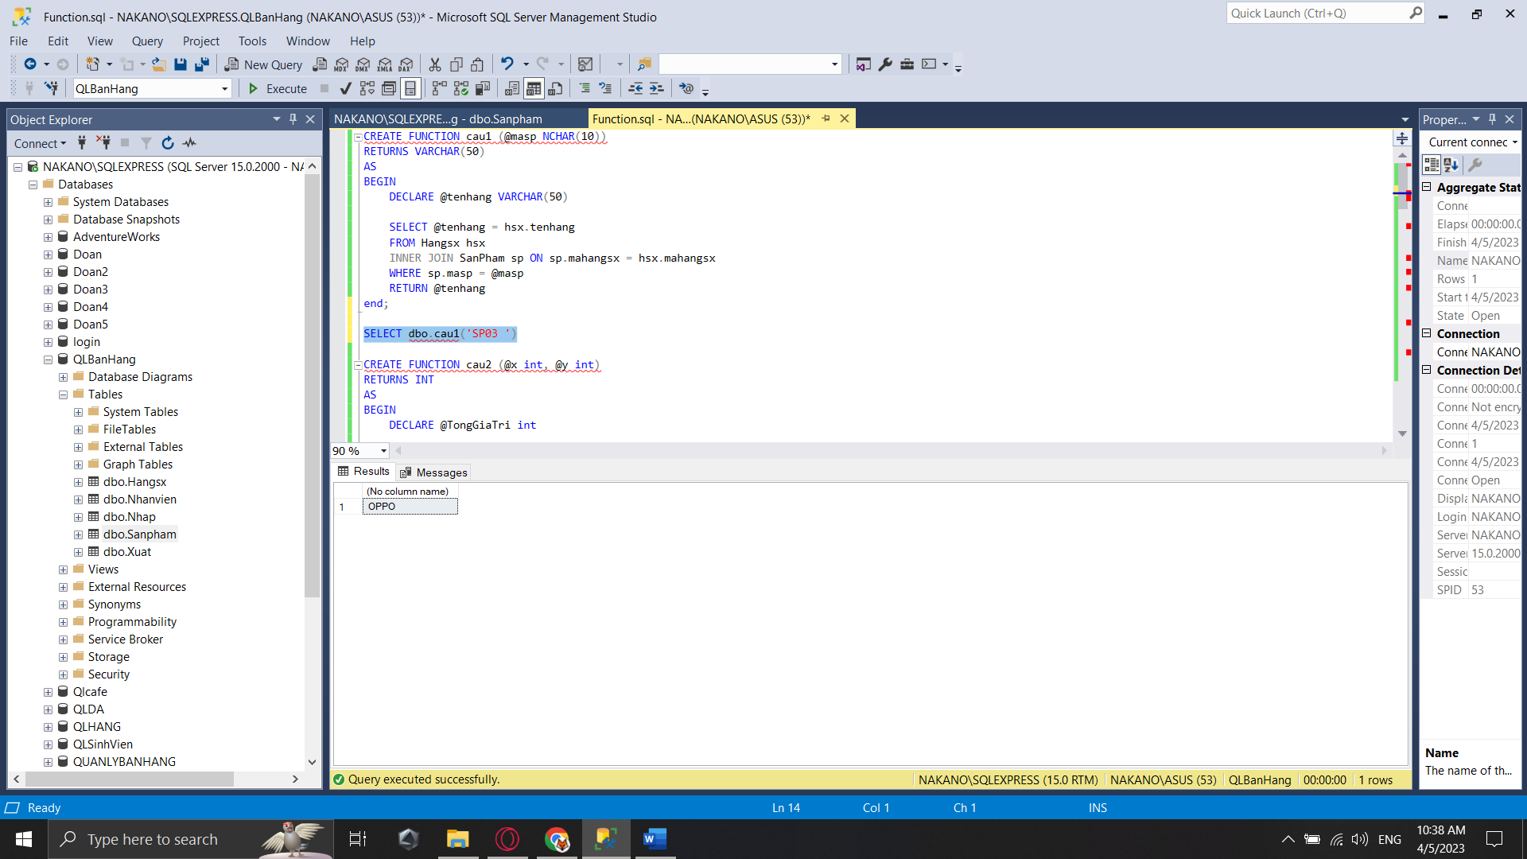

Câu 2:

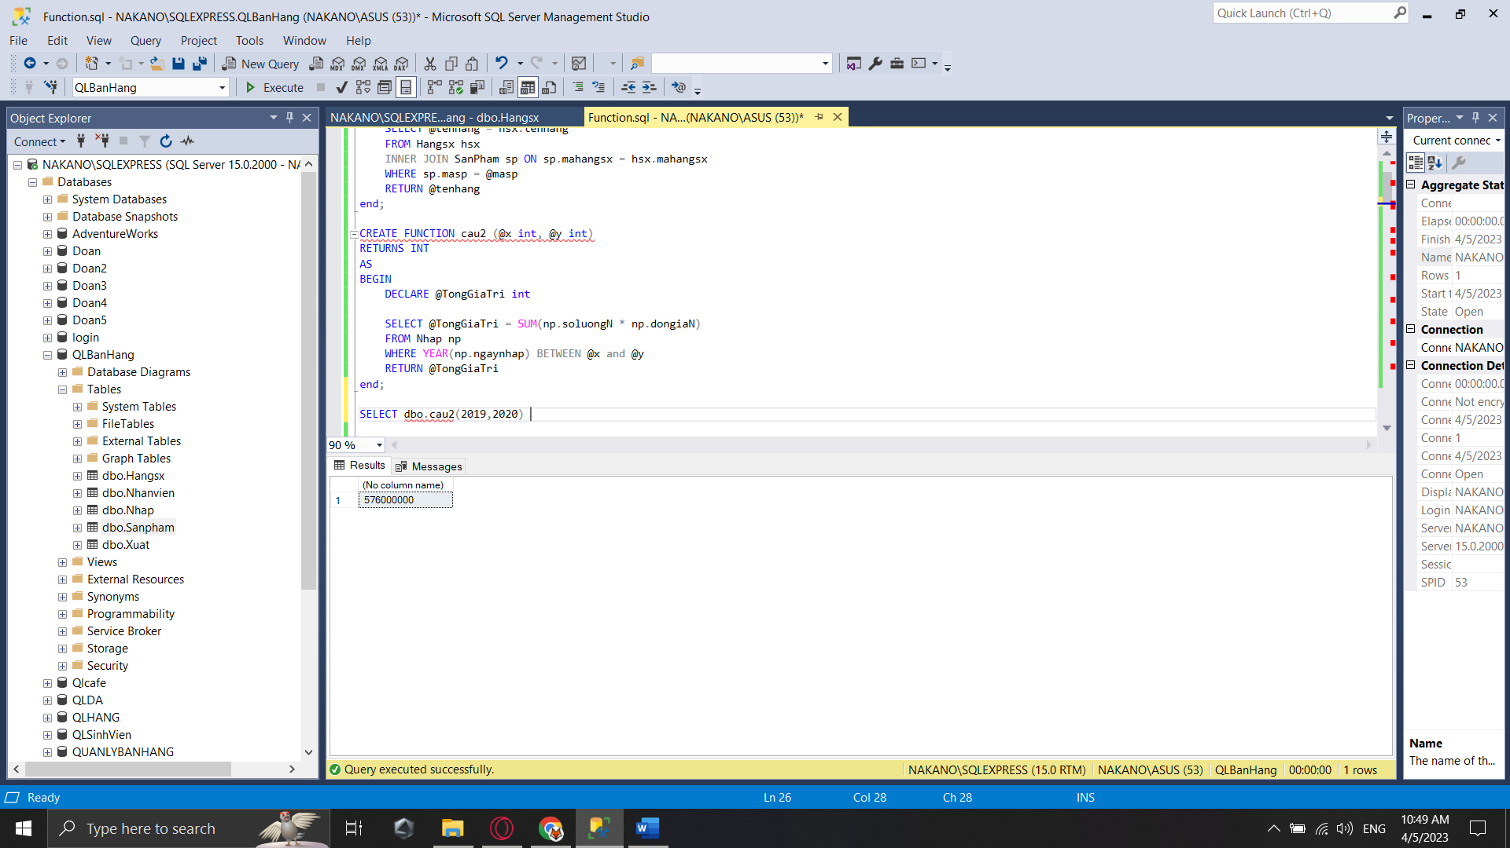

Câu 4:

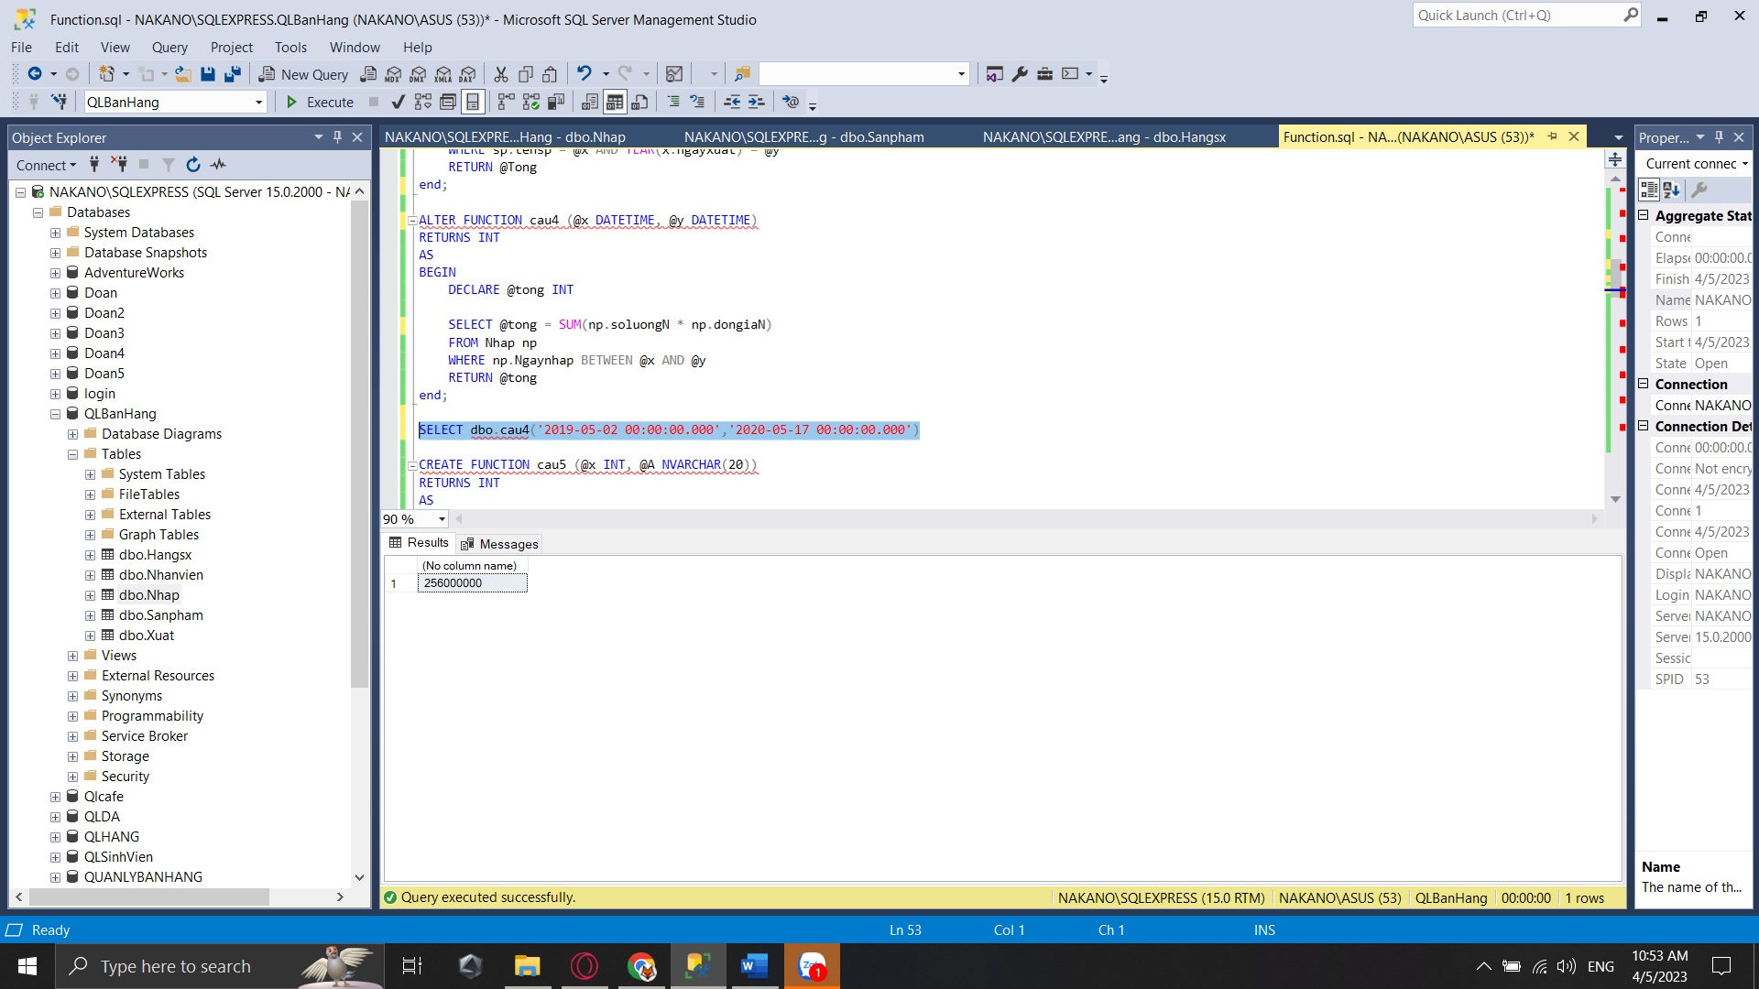

Câu 6:

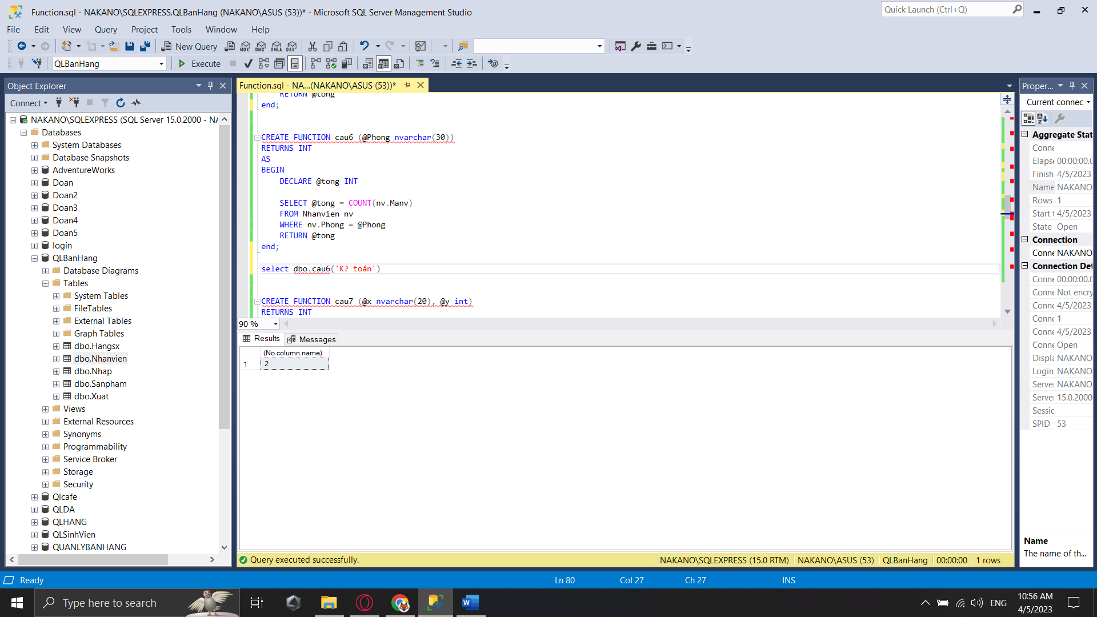

Câu 8:

Câu 10:

